|  |
| --- |
| Panopto: A guide to automatic recordings |

## Introduction

This document provides guidance on using Panopto during the automatic recording of timetabled sessions. You can check the availability of Panopto in your intended teaching space by visiting the Guided Learner Journey Module page "[List of rooms with Panopto capture facilities](https://herts.instructure.com/courses/15480/pages/rooms-with-panopto-recording-facilities)".

The following items will be addressed by this document:

* Preparing to record,
* What is being recorded,
* Notices, announcements and indicator lights,
* Pausing, resuming and stopping a recording,
* Considering the microphone,
* Using external devices including laptops and visualisers
* Ending your recording.

## Step 1: Preparing to record

Whether you intend to use a laptop or the lectern PC itself, in order to automatically record your lecture, the lectern PC must be switched on (see figure 1). Logging in to the lectern PC is also necessary to pause and resume your recording (see step 4).

## Step 2: Establish which screen will be recorded

It is important to note that not every room is configured in the same way, some rooms have two projectors while others have only one. In the case of having two projectors, only one of these will be recorded. While you cannot choose which screen to record, you can determine which is being recorded by examining the Crestron panel (figure 2). The relevant projector will show in writing “this screen will be recorded”.

In the case of the example above, the left screen (stage left) has been identified as the one configured to be recorded. To the audience this appears as the right screen as shown below (figure 3).

**Important**: In addition to recording what is presented on the projector, Panopto will automatically record the lectern PC’s desktop and any open PowerPoint presentations. Students will be able to view any of these recordings during playback.

## Step 3: Notices, announcements and indicator lights

Where a teaching room has been equipped to make automatic recordings, notices will be displayed on all entrances as well as inside the room. In addition, the lectern PC will have a notice on the desktop screen which you should display as students enter the room.

Just before you begin, you should remind students that the session is being recorded. As is made clear on all the notices, anyone wishing to be excluded from a recording can indicate this by raising their UH id card. If this happens you should pause the recording (F9) and resume when ready (F9) (see step 4).

In addition to notices, a light is attached to the lectern PC or installed into the lectern itself which will indicate the status of the recording as follows: The Blue light means “Note Recording, the yellow light means “Paused” and the red light means recording.

## Step 4: Pausing, resuming and stopping a recording

The ‘remote recorder’ is the software application that enables the automatic recording of your teaching session. It exists on the lectern PC, which as stated in Step 1, must remain powered on for the duration of your teaching session. The remote recorder allows the presenter to have full control over when to stop, pause or resume a recording, the status of which is indicated by the lights on the lectern (where available).

On lectern PC keyboard, the following hotkeys can be used to manage a recording:

* **F9** – Pause/Resume recording (toggle)
* **F10** – Stop recording

When pausing or resuming a recording, a pop-up notification will briefly appear above the lectern PC’s task bar (bottom-right). You can also click on the Panopto icon in the taskbar to select pause, resume and stop using the mouse if preferred.

**Examples of when to Pause/Resume (F9)**

* As students are entering or leaving the teaching session,
* A member of the audience raised their id card to indicate they wish to optout whilst asking a question,
* Your audience breaks in to groups to complete an activity,
* Your presentation contains a copyrighted film footage that is not covered by fair dealing.

**Example of when to Stop (F10)**

* You have a guest lecturer who hasn’t given their consent,
* Your Dean of School (or nominee) has agreed that the session does not need to be recorded (opt-out).

**Important:** If you stop an automatic recording, an alert window will ask you to confirm your wish to do so. Any subsequent recordings during the session will not be associated with your module website. If you wish to start a new recording, you should instead follow the guidance set out in “*Panopto: A guide to manual recordings*”

## Step 5: Considering the microphone

Be mindful that the type of the microphone available in your teaching space will provide an indication of the best position from which to address your audience and still have this captured in your recording at a reasonable quality. For example, some rooms are equipped with a fixed podium microphone that work best at 1-2 metres. Others have a longer-range podium microphone that works well at up to 4 or 5 metres (not shown below). Of course, some rooms will continue to have wireless microphones allowing for roaming and maximum flexibility (figure 4).

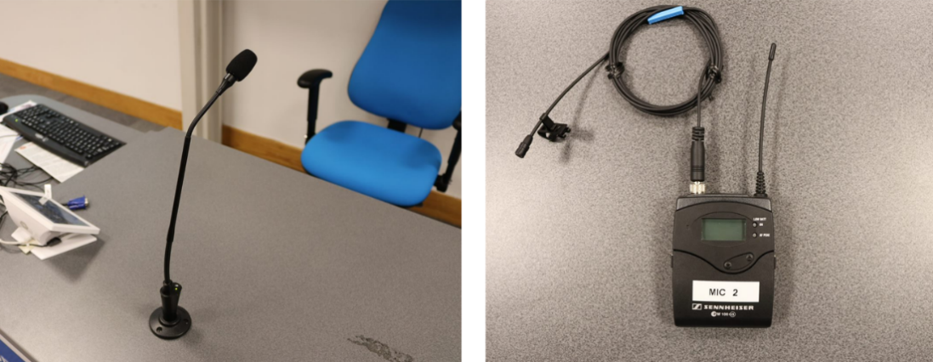

Figure 4, The podium microphone and a wireless microphone, side by side

## Step 6: Using external devices including laptops and visualisers

Should you wish to teach using external devices by way of laptops and visualisers, the Crestron panel will allow you to select these in the usual manner and project these onto the screen. As long the device is being projected onto the screen that is being recorded, any output will be included in your final recording.

**Important:**

* If you wish to stop, pause or resume a recording using the hotkeys, you will still need to use the keyboard attached to the lectern PC, not your laptop. For this reason, it is recommended that you always login to the lectern PC at the start of your teaching session, even if you only intend to present using your external device.
* If using an Apple device, the recommendation is to use VGA adapter instead of an HDMI cable when presenting for lecture capture to work seamlessly as shown in figure 5.

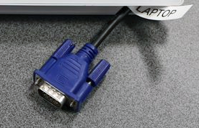

Figure 5, The lectern VGA cable

## Step 7: Ending your recording

Your recording will automatically stop at the end of your scheduled teaching session. However, it remains good practice to end your recording by pressing stop **(F10)** or pause **(F9)** on the keyboard.

**Recordings are uploaded to the associated Panopto module folder the following day. The footage will be automatically published on your StudyNet module after two working days. During this time period, you will be able to edit the recording via the Panopto interface, for details please see the guide, “*Panopto: A guide to editing your recordings*”.**

## Support and Guidance

* For more information about Panopto at UH including, instructional guides please see:
  + [Automatic recording of taught sessions on campus](https://herts.instructure.com/courses/15480/pages/automatic-recording-of-taught-sessions-on-campus?module_item_id=957456)
  + [Manual recording of taught sessions on campus](https://herts.instructure.com/courses/15480/pages/manual-recording-of-taught-sessions-on-campus?module_item_id=957458)
* For support with using the Creston panel, the lectern PC, lectern microphones, indicator lights please contact the helpdesk by emailing  [helpdesk@herts.ac.uk](mailto:helpdesk@herts.ac.uk) or call 4678.
* For help and guidance on using Panopto, please contact the Technology Enhanced Learning Team by emailing [TELSupport@herts.ac.uk](mailto:TELSupport@herts.ac.uk)

*Note:  The guidance given in this document may be updated from time to time to reflect changes in the Panopto application and the integration with UH systems.*